# **Tasks**

**Learners have to develop a dashboard to support the answers to the following questions and suggestions for places for newer restaurants.**

**Objective Questions**:

1. *What is the total no. of tables present in the data?*

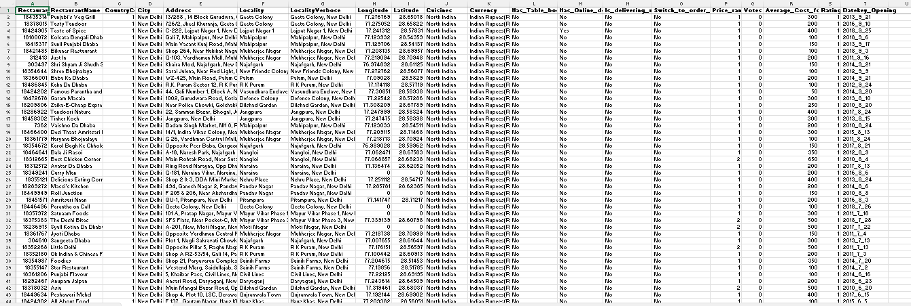

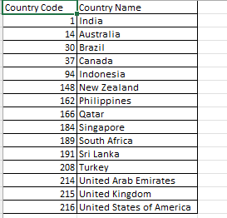

* We got two data sets: one with country the raw data and other with country data
* **Total tables present in the data** =2

1. *What is the total no. of attributes present in the data?*

The attributes of the table are:

1. Restaurant ID
2. Restaurant Name
3. Country Code
4. City
5. Address
6. Locality
7. Locality Verbose
8. Longitude
9. Latitude
10. Cuisines
11. Currency
12. Has_Table_Booking
13. Has_Online_Delivery
14. Is_delivering_now
15. Switch_to_order_menu
16. Price_range
17. Votes
18. Average_cost_for_two
19. Rating
20. Datekey_opening

**Total Number of attributes**: 20

1. *How many categorical columns are there in the data? [Search about categorical and continuous data, and try to answer this question]*

**Categorical Columns:**

1. Restaurant ID
2. Restaurant Name
3. CountryCode
4. Country Name
5. City
6. Address
7. Locality
8. Locality Verbose
9. Cuisines
10. Currency
11. Has Table Booking
12. Has Online Delivery
13. Is Delivering Now
14. Switch to Order Menu
15. Price Range

**Total Categorical Attributes: 15**

**Continuous Columns:**

1. Longitude
2. Latitude
3. Votes
4. Average Cost for Two
5. Rating

**Total Continuous Attributes: 5**

1. *The data consists of some inconsistent and missing values so ensure that the data used for further analysis is cleaned.*

* **Checked for missing values:** Firstly, identified the missing values in cuisines using filter, then filled the blank with the maximum ordered cuisine in the particular city*. (Created a new tab- “frequency table” to check the frequency of a cuisine in that particular area)*
* **Checked for inconsistent values:** Looked through the filters to check for any inconsistent data, any types, etc.
* **Standardized Data for Consistency:** 
  + Checked for inconsistent naming conventions in categorical columns like country names and cuisines, and made sure formatting was uniform., ensured **date values** in the Datekey_Opening column followed a date format.
  + Verified that **numerical columns** (e.g., Votes, Cost) were stored as numbers, and **text-based columns** were treated as strings.
* **Checked for Duplicates:** checked for duplicates using remove duplicates option in excel
* **Added New Columns:** 
  + Used text to columns to create a new column for Opening Year, Month and Date
  + Created new column to combine the currency sign and value for better readability
  + Created another tab for all the conversion rates, used VLOOKUP to bring the values in the raw data and further created another column for converting all the values in average cost of two into dollar.
  + Added another column to fill in the country name using country data into the raw data sheet using VLOOKUP

1. *Using the LookUp functions, fill up the countries in the original data using the country code.*

**Formula Used:** =VLOOKUP(C2,'country description'!$A$1:$B$16,2,0)

1. *Create a table to represent the number of restaurants opened in each country.*

**Pivot Table representation**

**Visual Representation:**

**Insight:**

* India overwhelmingly dominates the dataset with 8,652 restaurants — over 90% of the total entries — indicating a strong India-centric focus.
* The USA, despite being second, has only 434 restaurants, showing a steep drop-off after India.
* All other countries, including major markets like the UK, UAE, and Australia, have fewer than 100 entries each, suggesting limited presence and a potential opportunity to explore restaurant expansion in these underrepresented yet high-potential regions.

1. *Also, the management wants to look at the number of restaurants opened each year, so provide them with something here.*

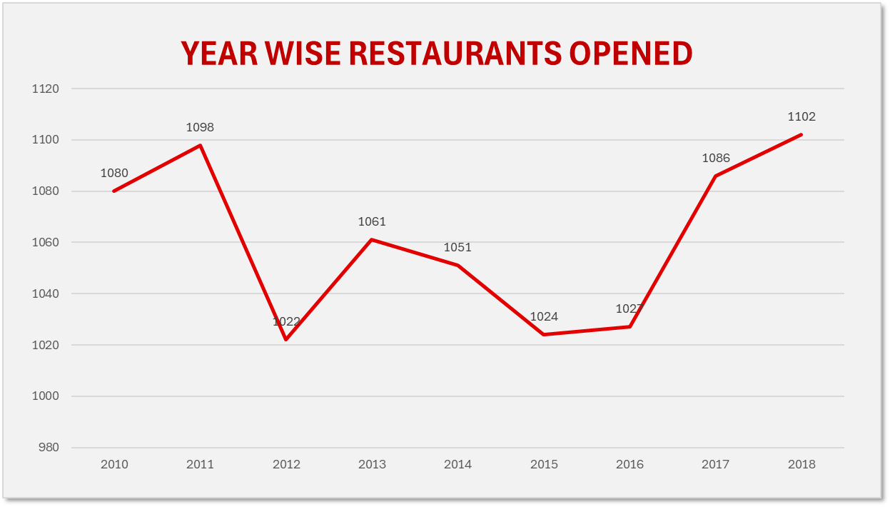

**Representation:** The chart shows the number of restaurants opened each year from 2010 to 2018.

**Insight:**

* The number of restaurants opened remained relatively stable with minor fluctuations, staying around the 1000–1100 range throughout the years.
* 2012 marked the lowest point (1022), followed by a steady recovery and eventual peak in 2018 with 1102 new restaurants — the highest in the 9-year span.
* The sharp rise post-2016 suggests renewed growth momentum, possibly driven by an increase in online delivery services

1. *What is the total number of restaurants in India in the price range of 4?*

**Representation:** This chart shows that India has 388 restaurants categorized under the highest price range (Price Range 4)

* **Insight:** There are 388 restaurants around india and which are price range greater than 4.It clears that around of 8652 there are 388 restaurants are in the price range of 4

1. *What is the average number of voters for the restaurants in each country according to the data?*

**Insight**: Indonesia stands out with the highest average votes (772), while countries like the UAE, Turkey, and the USA also show strong user engagement, in contrast to markets like Brazil and Singapore where customer interaction appears significantly lower.

1. *Calculate the average rating for all the restaurants that have price_range < 4 and provide online delivery. Use only the “IF” function, Logical Operators, and Aggregation functions to solve this problem.* ***[Note: Don’t use Conditional aggregation in this question.]***

**Formula Used: =**AVERAGEIFS('Cleaned Data'!W2:W9552,'Cleaned Data'!P2:P9552,"Yes",'Cleaned Data'!S2:S9552,"<4")

**Answer:**

1. *Using Conditional formatting highlight the rows of restaurants that are located in the countries or cities that you’ve suggested to the management for opening new restaurants.*

**Steps to achieve this:**1) Select the entire dataset  
2) Go to conditional formatting in home tab > New Rule > Use a formula to determine which cells to format

3) Wrote the formula: =OR($E2="Colombo", $E2="Tanunda", $E2="Rio de Janeiro", $E2="Beechworth", $E2="Sí£o Paulo")  
Cities taken in respect of Subjective Q2

4) Press Okay and the rows containing city names listed in the formula, got highlighted

1. *Create a new customized price column that consists of the abbreviation/symbol of the currency along with the Average_cost_for_two value. [Use string operations to do this task]*

|  |  |  |
| --- | --- | --- |
| **Currency** | **Sign** | **Average Cost of Two** |
| Indian Rupees | Rs. | Rs.200 |
| Dollar | $ | $70 |
| Brazilian Real | R$ | R$100 |
| Indonesian Rupiah | IDR | IDR70000 |
| NewZealand | $ | $90 |
| Botswana Pula | P | P1500 |
| Qatari Rial | QR | QR150 |
| Rand | R | R300 |
| Sri Lankan Rupee | LKR | LKR1000 |
| Turkish Lira | ₺ | ₺120 |
| Emirati Diram | AED | AED100 |
| Pounds | £ | £80 |

* **Insight:** The mentioned table represent the price along with their symbol of type money in prefix

1. *How can you create an array formula in Excel or Google Sheets to count the number of restaurants listed that do not offer online delivery, are in the lowest price range, and have an average cost for two people less than or equal to 250 Indian Rupees?*

**Note:** All the column numbers are in respect of “Cleaned Sheet” in the excel

**Steps to achieve this:**

1. Creating a new column, with all the values in INR (we had previously created a column where we converted all currencies to dollar, so now we simple convert add another column- column AC
2. Assumption: Lowest Price Range = 1
3. Formula used:

=COUNTIFS(P2:P9700, "No", S2:S9700, 1, AC2:AC9700, "<=250")

Answer is 1694

**Subjective Question:**

1. *Suggest a few countries where the team can open newer restaurants with lesser competition. Which visualization/technique will you use here to justify the suggestions?*

**Approach to the question:**

* 1. **Count of Restaurant:** To check the number of restaurants, to know which countries have the highest competition and which are not cluttered and has space for new restaurants

*To check the number of restaurants in each country:*

* India has the highest number of restaurants, followed by United States which shows high competition
* Canada has the lowest number of restaurants, which shows lowest competition, and opportunities
* From here we shortlist: Australia, Canada, Indonesia, Philippines, Qatar, Singapore, Sri Lanka, Brazil, New Zealand

**2) Checking the ratings:** To check the ratings of the restaurants, if the company has high number of restaurants, but low ratings then there is an opportunity for new restaurants to be opened

However, if the company has less number of restaurants but high ratings, then it would be a “low to moderate opportunity”

The highest opportunity lies in the placer where the count of restaurants is low and the ratings is also low

**Market Opportunity Insight**

* Countries like **Canada, Qatar, Singapore, Turkey, and Australia** show potential for premium, high-price range restaurants. They all have relatively few restaurants and average ratings that aren't particularly high, suggesting room for improvement in the dining scene.
* Canada and Singapore, in particular, stand out with very limited restaurant options and lower average ratings—making them attractive markets for introducing a higher-quality, upscale dining experience with minimal competition.
* While Qatar and Turkey have slightly better ratings, their smaller restaurant base still leaves space for a unique, high-end offering to stand out.
* The countries that have a rating >4, and less number of restaurants gives us the greatest potential. Hence, from here we shortlist: Sri Lanka, Singapore, Canada, Australia, Brazil

1. *Come up with the names of States and cities in the suggested countries suitable for opening restaurants.*





1. **Colombo, Sri Lanka**
   * **Sum of Votes:** 2,929
   * **Average Cost for Two:** $7.97
   * **Average Rating:** 3.87
   * **Why Here:** With a high number of votes and significant spending per visit, Colombo reflects an active and engaged customer base that’s willing to pay for quality. This suggests strong potential for a premium dining experience that meets growing consumer expectations.
2. **Tanunda, Australia**
   * **Sum of Votes:** 339
   * **Average Cost for Two:** $30
   * **Average Rating:** 4.4
   * **Why Here:** Despite its small size, Tanunda shows high customer engagement and consistently strong ratings, pointing to a loyal customer base and a community that values good food—ideal for establishing a well-loved restaurant with local appeal.
3. **Rio de Janeiro, Brazil**
   * **Sum of Votes:** 401
   * **Average Cost for Two:** $21
   * **Average Rating:** 4.315
   * **Why Here:** As a globally recognized tourist hub, Rio de Janeiro blends high footfall with above-average ratings and spend levels, making it a prime location for a restaurant that caters to both tourists and locals seeking memorable dining.
4. **Beechworth, Australia**
   * **Sum of Votes:** 237
   * **Average Cost for Two:** $20
   * **Average Rating:** 4.6
   * **Why Here:** Exceptional customer satisfaction reflected in its top-tier ratings makes Beechworth a promising spot for a boutique restaurant that thrives on word-of-mouth and repeat visits.
5. **São Paulo, Brazil**
   * **Sum of Votes:** 559
   * **Average Cost for Two:** $26
   * **Average Rating:** 3.68
   * **Why Here:** With a vast and diverse population, São Paulo represents a dynamic culinary landscape. While ratings are modest, the scale and spending power of the market open up opportunities for innovative or niche restaurant concepts to stand out.
6. Vineland Station, Canada:  
    **Sum of Votes:** 204
   * **Average Cost for Two:** $70
   * **Average Rating:** 4.3
   * **Why Here:** With the highest average rating and the highest customer engagement among the listed cities in Cands. Although the average cost for two is higher at $70 compared to others at $25, the strong ratings and high number of votes indicate that customers in Vineland Station are willing to pay more for quality dining experiences. This suggests a promising market for a premium restaurant, making it a strategic choice for expansion
7. *According to the countries you suggested, what is the current quality regarding ratings for restaurants that are open there?*

**Rating Overview & Insights**

* **Rating Range:** The ratings vary from 3.58 to 3.87, indicating generally positive feedback with slight variations across countries, suggesting moderate potential for improvement.

**Top Performers:**

* Sri Lanka leads with the highest average rating of 3.87, reflecting strong customer satisfaction and a promising market for expansion.
* Brazil follows closely with a rating of 3.85, indicating a vibrant dining market with good customer reception.

**Areas for Improvement:**

* Canada and Singapore have the lowest ratings at 3.58, highlighting opportunities to enhance the dining experience and better align with customer expectations.

**Actionable Recommendations**

* **Learn from the Leaders:** Investigate Sri Lanka and Brazil’s restaurant models to understand successful elements like menu design, service quality, and ambiance.
* **Enhance Experience in Lower-Rated Markets:** Focus efforts in Canada and Singapore on improving customer satisfaction through menu innovation, service upgrades, and experience enhancements.
* **Focus on Consistency & Training:** Prioritize operational consistency and invest in comprehensive staff training to deliver a superior dining experience consistently.
* **Use Feedback Constructively:** Actively encourage and analyze customer feedback, addressing concerns promptly to demonstrate a commitment to excellence.
* **Adapt to Local Preferences:** Tailor offerings to suit the local tastes, dietary habits, and service expectations of each market to better meet diverse customer needs.

1. *Also, what is the current expenditure on food in the suggested countries, so we can keep our financial expenditure in control?*

**Average cost for Two (converted in $) for all countries**

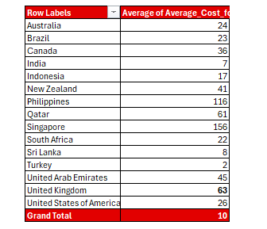

**Average cost for Two (converted in $) for suggested countries:**

**Cost Observations & Insights**

* **Sri Lanka:** The average cost for two is the most affordable at $8, suggesting that dining out is highly accessible and budget-friendly for local residents.
* **Higher-Cost Markets:** In contrast, Singapore tops the list with a significantly higher average cost of $156, followed by Canada at $36 and Australia at $24. These figures reflect the higher cost of living and premium positioning of dining experiences in these developed markets.

**Strategic Recommendations**

* **Market Considerations:** The sharp contrast in dining costs between developed nations like Singapore, Canada, and Australia versus Sri Lanka underlines the need for differentiated pricing strategies based on local economic conditions.
* **Pricing Strategy Implementation:** When entering high-cost markets like Singapore, businesses should align pricing with premium customer expectations, whereas adopting competitive, value-driven pricing in Sri Lanka could attract more customers and strengthen market presence.

1. *Come up with the names of restaurants from the recommended states that are our biggest competitors and also those that are rated in the lower brackets, i.e. 1-2 or 2-3.*

|  |  |
| --- | --- |
| **Row Labels** | **Average of Rating** |
| Canada | 3.575 |
| Chatham-Kent | 3.7 |
| Tokyo Sushi | 3.7 |
| Consort | 3 |
| Consort Restaurant | 3 |
| Vineland Station | 4.3 |
| Lake House Restaurant | 4.3 |
| Yorkton | 3.3 |
| Arigato Sushi | 3.3 |
| Qatar | 4.06 |
| Doha | 4.06 |
| 7st by Mumbai Spices | 3.4 |
| Aalishan | 3.8 |
| Applebee's | 3.8 |
| Coral - InterContinental Doha | 3.7 |
| Eatopia | 3.9 |
| Gokul Gujarati Restaurant | 4.3 |
| Gymkhana | 4.7 |
| Indian Coffee House | 3.4 |
| Mainland China Restaurant | 4.9 |
| MRA Bakery Sweets & Restaurant | 4 |
| Paper Moon | 4.5 |
| Ponderosa | 3.6 |
| Punjab Restaurant | 3.8 |
| Roti & Boti | 3.9 |
| Sabai Thai - The Westin Doha Hotel & Spa | 4.3 |
| Texas Roadhouse | 4 |
| The Manhattan FISH MARKET | 4 |
| Vine - The St. Regis | 4.4 |
| Zaffran Dining Experience | 4.6 |
| Zaoq | 4.2 |
| Singapore | 3.575 |
| Singapore | 3.575 |
| Al'frank Cookies | 4.2 |
| Artichoke Cafe | 3.2 |
| Artistry | 3.8 |
| Bitters & Love | 3.9 |
| Boufe Boutique Cafe | 3.2 |
| Chye Seng Huat Hardware | 3.7 |
| Colony | 3.8 |
| Cut By Wolfgang Puck | 4 |
| Fratini La Trattoria | 4.1 |
| I Am | 3.2 |
| Jaan | 3.8 |
| Makansutra Gluttons Bay | 3 |
| Potato Head Folk | 3.1 |
| Restaurant Andre | 3.8 |
| Rhubarb Le Restaurant | 3.9 |
| Sky On 57 | 3.4 |
| Summer Pavilion | 3.9 |
| Super Loco | 3.2 |
| The Lokal | 3.1 |
| The Refinery Singapore | 3.2 |
| Sri Lanka | 3.87 |
| Colombo | 3.87 |
| Arabian Knights | 4.2 |
| Burger's King | 4.1 |
| Butter Boutique | 4.2 |
| Cafe Beverly | 4.1 |
| Cafe Shaze | 3.8 |
| Carnival Ice Cream | 4.1 |
| Chinese Dragon Cafe | 3.4 |
| CIOCONAT Lounge | 3.7 |
| Cricket Club Cafe | 4.2 |
| Elite Indian Restaurant | 2.4 |
| Malay Restaurant | 3.5 |
| Ministry of Crab | 4.9 |
| Queen's Cafe | 2.5 |
| Simply Strawberries By Jagro | 4.5 |
| T.G.I. Friday's | 4 |
| The Commons | 4 |
| The Manhattan FISH MARKET | 4 |
| The Paddington | 3.6 |
| The Sizzle | 4.2 |
| Upali's | 4 |
| **Grand Total** | **3.81875** |

### HIGH-Rated Restaurants (3.1 to 3.5)

**Key Insights & Opportunities**

1. **Top Competitors in Brazil:**
   * **Kawa Sushi** (3.5) and **Paris 6 Classique** (3.4) are among the leading restaurants, reflecting strong customer satisfaction and competitive offerings in the Brazilian market.
2. **Culinary Diversity:**
   * Brazil’s restaurant scene offers a wide range of cuisines, from sushi to traditional Brazilian dishes, catering to diverse customer preferences and enhancing its appeal.
3. **Similar Ratings Across Markets:**
   * Brazil (3.24), **Canada** (3.3), and **Singapore** (3.2) show similar average ratings, indicating a competitive landscape in each of these countries and highlighting the need for differentiation.
4. **Potential for Growth:**
   * Restaurants with ratings around **3.1** (e.g., **Gopala Hari** and **Sushi Loko**) have room for improvement. Enhancing their menu offerings or service could elevate their ratings and overall market appeal.
5. **Competitive Landscape in Singapore:**
   * Several restaurants in Singapore have ratings of **3.2**, reflecting a vibrant market with healthy competition, particularly in the casual dining and café sectors.
6. **Focus on Quality:**
   * Restaurants with ratings of **3.4** and above demonstrate that consistent, high-quality experiences are crucial for attracting and retaining customers in a competitive market.

|  |  |
| --- | --- |
| **country and city restaurant** | **Average of Rating** |
| **Brazil** | **1** |
| **Cantinho da Gula** | **1** |
| Sí£o Paulo | 1 |
| **Divino Fogí£o** | **1** |
| Sí£o Paulo | 1 |
| **Quiosque Chopp Brahma** | **1** |
| Rio de Janeiro | 1 |
| **Sandubas Cafí©** | **1** |
| Brasí_lia | 1 |
| **Super Grill** | **1** |
| Sí£o Paulo | 1 |
| **India** | **1.004467194** |
| **United Kingdom** | **1** |
| **Damascena Coffee House** | **1** |
| Birmingham | 1 |
| **United States of America** | **1** |
| **Frick's Tap** | **1** |
| Davenport | 1 |
| **Los Agaves** | **1** |
| Davenport | 1 |
| **Nosh Mahal** | **1** |
| Pocatello | 1 |
| **Grand Total** | **1.004448563** |

### Low-Rated Restaurants (1 to 2)

**Key Insights & Opportunities for Improvement**

1. **Widespread Low Ratings:**
   * Several restaurants across countries like Brazil, India, the UK, and the USA have consistently low ratings (around 1), indicating a pattern of customer dissatisfaction that requires urgent attention.
2. **Concentration of Issues in Specific Locations:**
   * In Brazil, cities like São Paulo and Brasília feature multiple low-rated restaurants, suggesting that local factors such as service or food quality may be contributing to these poor reviews.
3. **Global Reach of Low Ratings:**
   * The prevalence of low ratings is not isolated to any one region. It’s a global issue affecting markets across Brazil, India, the UK, and the USA, pointing to a more widespread challenge for certain dining establishments.
4. **Opportunity for Recovery:**
   * Restaurants with ratings of 1 have considerable room to improve. By actively addressing customer feedback, these businesses have the potential to significantly enhance their offerings and customer satisfaction.
5. **Reputation Risks:**
   * Such low ratings can tarnish a restaurant’s reputation and erode customer trust. This could deter potential customers and negatively impact long-term business performance.
6. **Engaging with Customers for Improvement:**
   * Restaurants facing these low ratings could benefit from direct customer engagement. Understanding their concerns and making targeted improvements could lead to higher ratings and better customer retention.
7. Which cuisines should we focus on in the newer restaurants to get better feedback? Does the choice of cuisines affect the restaurant ratings?

|  |  |  |
| --- | --- | --- |
| **CUISINES CITY AND COUNTRY** | **Average of Rating** | **Sum of Votes** |
| **American, BBQ, Sandwich** | **4.9** | **1252** |
| **Orlando** | **4.9** | **1252** |
| United States of America | 4.9 | 1252 |
| **American, Burger, Grill** | **4.9** | **162** |
| **Manchester** | **4.9** | **162** |
| United Kingdom | 4.9 | 162 |
| **American, Caribbean, Seafood** | **4.9** | **548** |
| **Augusta** | **4.9** | **548** |
| United States of America | 4.9 | 548 |
| **American, Coffee and Tea** | **4.9** | **570** |
| **Des Moines** | **4.9** | **570** |
| United States of America | 4.9 | 570 |
| **American, Sandwich, Tea** | **4.9** | **1457** |
| **Orlando** | **4.9** | **1457** |
| United States of America | 4.9 | 1457 |
| **BBQ, Breakfast, Southern** | **4.9** | **249** |
| **Dalton** | **4.9** | **249** |
| United States of America | 4.9 | 249 |
| **Burger, Bar Food, Steak** | **4.9** | **2238** |
| **Pensacola** | **4.9** | **2238** |
| United States of America | 4.9 | 2238 |
| **Continental, Indian** | **4.9** | **641** |
| **Dubai** | **4.9** | **641** |
| United Arab Emirates | 4.9 | 641 |
| **European, Asian, Indian** | **4.9** | **621** |
| **Pasay City** | **4.9** | **621** |
| Philippines | 4.9 | 621 |
| **European, Contemporary** | **4.9** | **441** |
| **Inner City** | **4.9** | **441** |
| South Africa | 4.9 | 441 |
| **European, German** | **4.9** | **1413** |
| **Tampa Bay** | **4.9** | **1413** |
| United States of America | 4.9 | 1413 |
| **Hawaiian, Seafood** | **4.9** | **1343** |
| **Rest of Hawaii** | **4.9** | **1343** |
| United States of America | 4.9 | 1343 |
| **Italian, Bakery, Continental** | **4.9** | **322** |
| **Jaipur** | **4.9** | **322** |
| India | 4.9 | 322 |
| **Italian, Deli** | **4.9** | **1424** |
| **Tampa Bay** | **4.9** | **1424** |
| United States of America | 4.9 | 1424 |
| **Mexican, American, Healthy Food** | **4.9** | **223** |
| **Gurgaon** | **4.9** | **223** |
| India | 4.9 | 223 |
| **Mughlai, Lucknowi** | **4.9** | **1057** |
| **Lucknow** | **4.9** | **1057** |
| India | 4.9 | 1057 |
| **Sunda, Indonesian** | **4.9** | **5514** |
| **Jakarta** | **4.9** | **3302** |
| Indonesia | 4.9 | 3302 |
| **Tangerang** | **4.9** | **2212** |
| Indonesia | 4.9 | 2212 |
| **World Cuisine** | **4.9** | **95** |
| **Ankara** | **4.9** | **95** |
| Turkey | 4.9 | 95 |
| **Grand Total** | **4.9** | **19570** |

**Culinary Trends & Insights**

1. **Overall High Satisfaction:**
   * All listed cuisines maintain an impressive average rating of **4.9**, reflecting a strong level of customer satisfaction and consistent positive experiences across the board.
2. **Popularity of American Cuisine:**
   * **American dishes** such as BBQ, burgers, and seafood are particularly favoured, with high ratings in cities like **Orlando** and **Pensacola**, showcasing their widespread appeal in the U.S. market.
3. **Indonesian Cuisine on the Rise:**
   * **Sunda cuisine** in **Jakarta** stands out with the highest engagement, receiving **5,514 votes**, highlighting the deep-rooted popularity and growing demand for Indonesian flavors in the region.
4. **Strong Demand for Indian Flavors:**
   * **Mughlai** and **Continental Indian** cuisines are highly rated in **India**, indicating a dedicated customer base that values these rich, flavorful offerings and a steady market for regional dishes.
5. **Diverse Regional Preferences:**
   * Different cities exhibit unique culinary tastes, with **Dubai** and **Pasay City** showing a strong preference for a fusion of **European** and **Asian cuisines**, reflecting a blend of global influences in local dining scenes.
6. **Limited Interest in World Cuisine:**
   * The **World Cuisine** category sees relatively low engagement, with just **95 votes**, suggesting that customers in these regions may not be as interested in globally diverse options as in other more specific culinary categories.
7. *According to our current data, should we go for online delivery and table booking? Does that affect the customer’s ratings?*

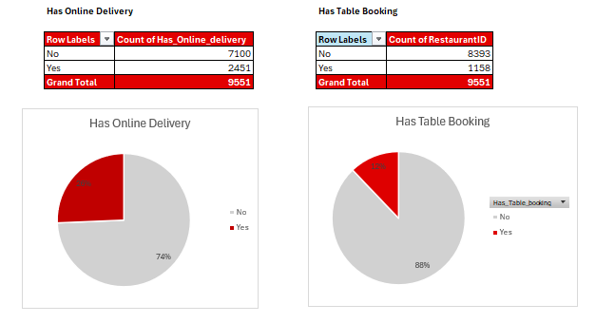

**Country-wise Distribution**

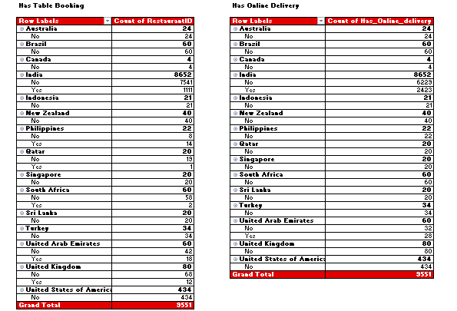

**For the suggested country:**

**Average Rating:**

**Insights:**

* **Restaurant Services Analysis:**
  + The analysis focuses on countries where restaurants are recommended for new openings, specifically noting the lack of **table booking** and **online delivery** options, which could represent an untapped opportunity in these markets.
  + On the other hand, countries like Philippines, Qatar, South Africa, UAE, UK has a table booking option, and all these countries have an average rating greater than 4.

**Recommendations:**

* **Strategic Service Introduction:**
  + Given the absence of **table booking** and **online delivery** in many of these regions, introducing these services would serve as a competitive edge. By offering these customer-centric services, restaurants can quickly attract and retain customers, capitalizing on a gap in the current market offering.

1. *Should the team keep the rate of cuisines higher? Will that affect the feedback? According to our data are the rates of cuisines and ratings, correlated?*

**Approach:** We take the country, average cost of two ($) and average rating from our data and using the correl function observe the relationship between the cost and rating:

Here we can observe that, If we apply, correlation function,

=correl (average ratings, average of average cost of two ($)

OR

=CORREL(C708:C727,D708:D727)

It comes out to be 0.103, which shows that price and ratings are positively correlated, but is closer to 0, which shows that if we increase the price then along with these ratings will also go up, but the intensity of this relation will be very low, hence, this factor can be ignored

As we see from the chart as well, the rating is moving in the direction, same as the price

1. *What is the distribution of the number of restaurants of different price ranges in all the countries?*

|  |  |
| --- | --- |
| **CUISINE** | **Count of Restaurant Name** |
| 1 | 4444 |
| 2 | 3113 |
| 3 | 1408 |
| 4 | 586 |

**Key Insights:**

* **Prevalence of Lower and Mid-Price Ranges:**
  + The dataset shows that **42%** of restaurants fall within the lowest price range, while **35%** are in the next price tier, indicating that the majority of dining options are focused on affordable to mid-range offerings.
* **Limited High-End Options:**
  + There is a noticeable lack of restaurants in the higher price ranges, pointing to an opportunity to introduce more **mid-to-high-end dining establishments** that cater to customers seeking premium experiences.

1. *Explain your approach in brief for suggesting countries/cities in order to open new restaurants, if the objective and subjective questions would have not been given to assist you.* ***[you have to give bullet pointers in order to answer this question]***

**Analysis & Recommendations for New Restaurant Openings**

* **Comprehensive Analysis:**
  + Based on a thorough evaluation of the dataset, including various conditions, filters, and visual charts, I have identified key insights for opening new restaurants.
* **Suggested Countries:**
  + **Canada, Qatar, Indonesia, Singapore, Philippines,** and **Sri Lanka** are recommended for new restaurant openings due to their emerging markets and growth potential.
* **Preferred Cuisines:**
  + The cuisines with the best ratings include **Cafe, Chinese, North Indian,** and **Mughlai**, which are suggested based on their strong customer reception and market demand.
* **Cost Management:**
  + To align with customer spending patterns, it is crucial for the team to carefully manage food costs, ensuring offerings remain affordable without compromising on quality.
* **Market Gaps:**
  + Currently, the number of restaurants in the suggested countries is lower compared to other regions, presenting an opportunity to fill this gap with new dining options.
* **Strategic Recommendations:**
  + I have provided specific restaurant counts for each suggested country, helping to prioritize areas with the highest potential.
* **Service Differentiation:**
  + Introducing **Table Booking** and **Online Delivery** services would give us a competitive advantage, allowing us to attract a broader customer base and meet growing demand for convenience.